
LAMP – Objective & Mission
Mission Statement: To connect Muslim professionals with undergraduate students in
need of career, professional, and/or leadership advice and guidance, with the ultimate
goal of establishing long term, mutually beneficial, mentor-mentee relationships.

The Mentor-Mentee Relationship
Mentoring is a relationship that is developed to help coach, motivate, and train leadership and career skills in a specific field of interest for a Mentee. The mentoring relationship is both rewarding, and helps impact the career choices and development of a young professional. A LAMP mentee is one who is seeking professional mentorship support, coaching, and education prior to launching into the working world. |  | 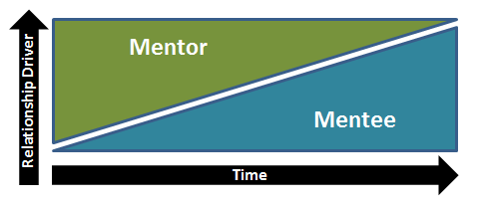

Mentee Role & Expectations
Begin by discussing roles and responsibilities of each side in the relationship with your Mentor. Check if roles within the relationship are suitable for needs and focus areas as a mentee along with what the mentor can contribute. Then, discuss how the role can support the mentoring needs such as networking, resume advice, job shadowing, and more. |  | Mentor’s should be the initial drive in the relationship. As time progresses, the Mentee can further maintain and drive the relationship.

Code of Conduct
The mentor-mentee relationship should be based on respectful Islamic and business etiquette. Both mentors and mentees should be mindful of commitments, meeting times, and relationship investment. To adhere to Islamic principles, Mentees will be primarily paired with the respective same gender. If in the case of different genders, LAMP admin will be cc’d on communications.

Where do I begin?
Learn & Discuss:  - Mentor strengths and career experience  - How the mentor relates to your career field  - Identify your strengths and weaknesses as the Mentee  - Communicate and explore short and long-term career goals  - Make visible career aspirations  - Development goals | Set Mentor-Mentee Expectations:  - Time commitments  - Mentor Role  - Mentee Role

What are the action items?
Potential Activities:
- Review the Mentor’s work history and your resume together
- Exchange and discuss materials written by each side (e.g. articles, papers)
- Discuss potential for on the job shadowing
- Network with Mentor’s connections and other colleagues
- Present the work products and seek feedback on communicating ideas, writing with clarity, etc.
- Attend professional association meetings, conferences, events together
- Meet informally for lunch or dinner

Discussion Topics:
- Discuss relevant assignments & coursework
- Strengths in the areas of knowledge, experience and capabilities
- Needs in the areas of knowledge, experience and capabilities
- Career Interests & College Major
- Mentor’s career path and experiences
- Future continuing learning goals
- Networking tips & advice

