
LAMP – Objective & Mission
Mission Statement: To connect Chicago area Muslim professionals with undergraduate students in
need of career, professional, and/or leadership advice and guidance, with the ultimate
goal of establishing long term, mutually beneficial, mentor-mentee relationships.

Why Mentor?
Mentoring is a relationship that is developed to help coach, motivate, and train leadership and career skills in a specific field of interest. The mentoring relationship is both rewarding, and helps impact the career choices and development of a young professional. A LAMP mentor is one who is willing to contribute time, energy, and resources to mentee(s) in helping to support their growth and launch into the professional working world. |  | 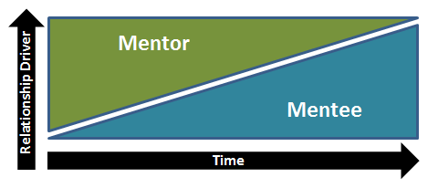

Mentor Role & Expectations
Begin by discussing roles and responsibilities of each side in the relationship. Check if roles within the relationship are suitable for the needs of the mentee along with what you can contribute as a mentor. Then, discuss how the role can support the mentoring needs such as networking, resume advice, job shadowing, and more. |  | Mentor’s should be the initial drive in the relationship. As time progresses, the Mentee can further maintain and drive the relationship.

Code of Conduct
The mentor-mentee relationship should be based on respectful business etiquette. Both mentors and mentees should be mindful of commitments, meeting times, and relationship investment. To adhere to Islamic principles, Mentees will be primarily paired with the respective same gender. If in the case of different genders, LAMP will be cc’d on communications.

Where do I begin?
Learn about the Mentee:  - Mentee development needs  - Specific skills needed for major/field of choice  - Strengths and weaknesses as identified by the mentee or others  - Short and long-term career goals  - Career aspirations  - Development goals | Set Mentor-Mentee Expectations:  - Time commitments  - Mentor Role  - Mentee Role

What are the action items?
Potential Activities:
- Review the mentee’s work history and resume together
- Exchange and discuss materials written by each side (e.g. articles, papers)
- On the job shadowing
- Network and introduce the mentee to other colleagues
- Review the mentee’s work products and provide feedback on communicating ideas, writing with clarity, etc.
- Attend professional association meetings, conferences, events together
- Meet informally for lunch or dinner

Discussion Topics:
- Discuss relevant assignments & coursework
- Mentee’s strengths in the areas of knowledge, experience and capabilities
- Mentee’s needs in the areas of knowledge, experience and capabilities
- Career Interests & College Major
- Mentor’s career path and experiences
- Future continuing learning goals
- Networking tips & advice

